Parents Plus Early Years Programme (PPEY)
Facilitator Training

This Facilitator Training for professionals will take place over five morning sessions on zoom (9.15am-1:30pm) and will equip participants to use this programme with parents both in groups and individually and in online and face to face settings. In addition, it gives you a structure and solution focused method for providing Individual Family Sessions to enhance family problem solving.
The training is interactive with lots of opportunities for participation and group learning. There are regular screen breaks and one longer tea break for 15 mins at 11/11.15am. See the breakdown of the structure and content of the training modules below, though the exact format of training will be tailored to the needs of the participants. To enhance learning participants may be invited to complete a short assignment between sessions.

Module | Topics Covered
1 | Introductions and Programme Overview  Setting your Training Goals  Background to PPEY, Research and Evidence base  Introduction Video  Navigating the Programme Materials  Review of delivery models: Group intervention, combining group and individual sessions 8-10 weeks b) As an individual programme delivered to parents in the home over a period of up to one year. C) short workshops tailored to the needs of your parents  Begin familiarising with Topics
2 | Familiarising with the Topics  Familiarising with further topics  Programme content Practice exercises (Small Group Work/Breakouts)  Preparation for Session Planning and Group Work facilitation/Delivery skills practice  Group Work and Facilitation Skills
3 | Planning a group session (Small Group Work/Breakouts)  Practice exercise- Delivering a group session (Small Group Work/Breakouts)  Dealing with challenges - group dynamics, complex and varying needs, time management and other topics arising
4 | Ensuring / monitoring the Running of a Good Quality Programme  PP Quality Protocol - gaining parent feedback and reviewing progress  Post training Supervision & the Parents Plus Accreditation Process  More on a Strengths Based Model & Core solution-focused facilitator skills  Practice Exercise - Conducting ‘Review of the Week’  Practice Exercise - Individual Goal Setting – Pre programme meetings  Getting groups started, group design, engaging parents, responding to challenges  Short workshop delivery Format  Engaging Parents, getting buy-in and motivation
5 | Individual family delivery (parent goals, portfolio folder, video practice)  Explore 16 Topics - Parent Pack  Family Sessions  Video Feedback Sessions with Parents and Children  Practice exercise – Giving Strengths Based feedback to parents (Small Group Work/Breakouts)  More on managing challenges - programme delivery in your service context  What's Next ..

A copy of the PPEY Facilitators Manual, Parent Book and Parent Pack are required for the duration of the training modules. Full attendance for the 5 modules is required for certification and we ask each participant to complete a feedback form at the end of each day. This feedback will help us fine-tune the training modules to ensure you get the most out of your Parents Plus training.

To enhance the Learning, Participants are invited to look over the materials in advance of each module, and you may be asked to carry out a task between modules.

Learning Outcomes: By the end of this Training attendees will:
- Understand the core components of the PPEY and be ready to use the programme with parents and children, in groups, individually and in workshops.
- Demonstrate key skills in the strengths-based parent engagement model, facilitating solution-focused group work with parents, including engagement, retention and responding constructively to challenges.
Group Delivery Format
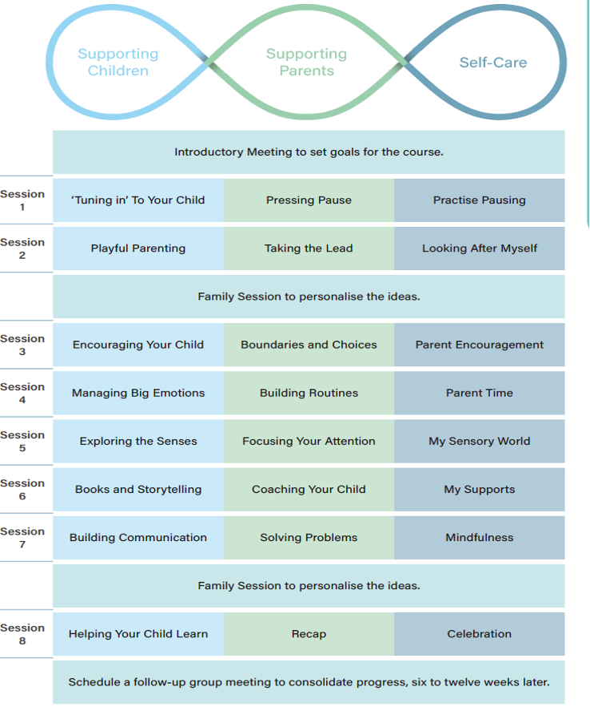
Individual Topic Delivery

